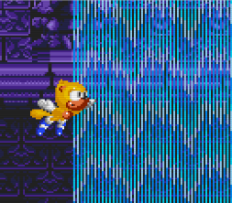Introduction:

What are extra slot characters?

There are character mods with custom movesets, sprites, HUD, and much more, that do not replace Sonic, Tails, or Knuckles.

This is made easier with the help of the framework, with built-in functions and features and a detailed document that can help you have all the necessary functions for your characters.

**Important:**

Make sure to download the framework here and in your mod list, the framework must be below the Extra Slot character.

<https://sonic3air.boards.net/thread/28/esu-framework>

You may want to reserve your character slot if you want to share your extra slot character with the world, so that your slot has not already been chosen and/or conflicts with another reserved slot.

To add your characters' IDs to the registered list, you need to follow few simple steps:

Register on github.com if you haven't already.

Go to <https://randomizer.extra-character-slots.com/> and generate any ID.

Go to <https://github.com/Cloudydude/ECSv8-Character-ID-Randomizer> and make a fork of this repository.

**Recommended tools**

Sonic 3 Animation editor

<https://files.gamebanana.com/tools/setup_3b4e2.exe>

Any software for sprites (recommend Graphics gale or asesprite or gimp)

<https://www.gimp.org/downloads/>

[https://www.aseprite.org/#buy](https://www.aseprite.org/%23buy)

<https://graphicsgale.com/us/>

For coding use Visual studio or notepad++

<https://code.visualstudio.com/>

<https://notepad-plus-plus.org/downloads/>

For visual code make sure you click on this icon to enter the marketplace

Then type s3air and you will find the plugin needed for lemon scripting.

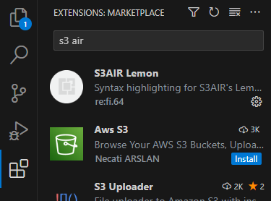

Part 1 : The basics.

We will start with some basic things we need to do to set up or extra slot character.

First make a folder, you can call it anything, in this tutorial, we will call it ES example.



In this folder, we must make 3 more folders, and call them palettes, scripts and sprites.



Next, we must have a mod.json file. Have this file and use it in your folder:

<https://cdn.discordapp.com/attachments/1104981939938668605/1107371230710988951/mod.json>

Next we need to set up sprites for our characters and a spritesheet. If you already have a character in mind and all the sprites needed ready, you can skip this part.

Go to sonic3air_game\doc\modding\sprites in your zip file of sonic 3 air.

Then get the following files that will be used for this tutorial.

hud_life_sprites.json

hud_life_sprites.png

hud_text_sprites.json

monitors.bmp

monitors.json

result_nameplate.json

If your Es character is based on Sonic, get the following files:

signpost_sonic.bmp

bluesphere_sonic.bmp

bluesphere_sonic.json

character_sonic.bmp

character_sonic.json

character_sonic_dropdash.json

character_sonic_peelout.bmp

character_sonic_peelout.json

character_sonic_snowboarding.bmp

character_sonic_snowboarding.json

character_supersonic.bmp

character_supersonic.json

continue_icon_sonic_wait.bmp

character_sonic_ending.json

character_sonic_ending.bmp

continue_icon_sonic_wait.bmp

continue_icon_sonic_wait.json

endpose_sonic.bmp

endpose_sonic.json

endpose_supersonic.bmp

endpose_supersonic.json

character_sonic_continue.bmp

character_sonic_continue.json

character_sonic_ending.bmp

endpose_supersonic.json

endpose_supersonic.bmp

If your Es character is based on Tails, get the following files instead:

character_tails.bmp

character_tails.json

character_tails_continue.bmp

character_tails_continue.json

character_tails_ending.bmp

character_tails_ending.json

character_tails_tails.bmp

character_tails_tails.json

character_tails_tails_ending.bmp

character_tails_tails_ending.json

continue_icon_tails_tails_wait.bmp

continue_icon_tails_tails_wait.json

continue_icon_tails_wait.bmp

continue_icon_tails_wait.json

signpost_tails.bmp

If your Es character is based on Knuckles, get the following files instead:

continue_icon_knuckles_wait.json

continue_icon_knuckles_wait.bmp

character_knuckles_continue.json

character_knuckles_continue.bmp

character_knuckles.json

character_knuckles.bmp

bluesphere_knuckles.json

bluesphere_knuckles.bmp

tornado_knuckles.json

tornado_knuckles.bmp

signpost_knuckles.bmp

endpose_knuckles.json

endpose_knuckles.bmp

We will deal with the cutscene sprites for Knuckles soon.

Then put them all together in the sprites folder.

Now go to sonic3air_game\doc\modding\palettes.

Depending on which character you chose, get their character_palette_(character) and bluesphere_palette_(character) files. Then put them on the palletes folder.

After that, replace the (character) with your reserved slot name. Like the following:

